3. Industry & Technology Landscape Analysis
This section analyses the current cybersecurity training environment relevant to Axiom and compares existing technologies, platforms and security frameworks that address practical cybersecurity learning. As Axiom is a new product for InspireCyber, there is no existing Axiom system or internal workflow that can be accurately documented as a traditional organisational “as-is” process. Therefore, the current-state analysis focuses on the existing training approaches and the capability gap identified for AI-enabled workplace cybersecurity training. The analysis is used to identify suitable technologies and establish the specific gaps that the proposed Axiom MVP will address.

3.1 Current State Assessment (As-Is Analysis)
Axiom is being created as a new cybersecurity training product and not as an alternative to the existing InspireCyber product. Thus, the current state is best described by the overall cybersecurity training ecosystem. The existing platforms already have practical laboratories, tutorials, simulations, gamification, and tracking tools. This approach shows that cybersecurity learners can greatly benefit from the activities and scenarios instead of theoretical training only.
For instance, TryHackMe offers browser-based cybersecurity labs and learning pathways that cover offensive, defensive, and other aspects of cybersecurity. The company's business platform includes assignment creation and tracking options. Retrospect Labs' Gauntlet is a system that offers structured cybersecurity tutorials and includes scenario management, injections, participant management, and activity metrics. The above examples show the existing workflow where the user gets the scenario, does the activities, accomplishes the objectives, and gets measurable results.
But, the existing training situation doesn’t seem to fit into the particular training goal of Axiom. As identified in the project brief, there are workplace dangers related to AI, including prompt injection, compromised chatbots, and data leakage. After consultation with the client, the Axiom MVP has been reduced to two scenarios: Prompt Injection in an AI Chatbot and AI-enabled Data Leakage. The aim is to let learners identify AI-related evidence, understand what has happened and take appropriate workplace action.
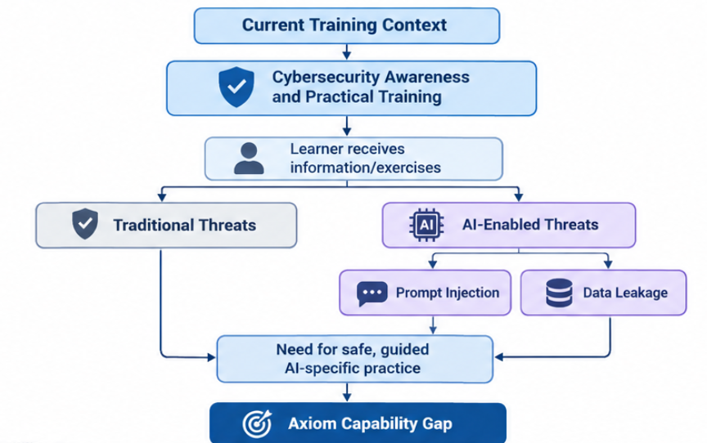
Figure 3.1: Current training context and capability gap

As shown in Figure 3.1, there is already practical cybersecurity training available, however, the particular combination of artificial intelligence-based workplace scenarios, investigative activities and learning process is the defined gap. Thus, the proposed training experience should be more than just any cybersecurity training, but should include realistic workplace situations.

The client has confirmed that learners need to investigate virtual workplace artefacts like messages, documents and company data. These artefacts need to be virtual reproductions rather than functional production tools. The client has also confirmed that Axiom is going to be an independent web application with React being the preferred option for UI development and Python being one of the possible options for the backend. Red and Blue training activities will be two independent scenarios at the start.

There is no internal InspireCyber data available to determine the number of training hours, the rate of errors and losses suffered due to cybersecurity threats. Thus, unsupported statistics were not provided. Instead, the system will produce measurable results like the time spent, objectives completed, hints needed, the overall score and feedback from learners.

3.2 Technology & Market Survey
The technology review assessed currently available cybersecurity training systems as well as security frameworks that may serve as a guide when developing Axiom. The chosen systems demonstrate various ways of practical training, testing, and cybersecurity management.
TryHackMe
TryHackMe is an online cybersecurity education tool that delivers hands-on laboratories and guided training sessions. In terms of its business product, it enables assignments and customized learning content and tracking. Its guided nature is especially important considering that Axiom is supposed to cater to individuals who may lack advanced technical cybersecurity knowledge.
The drawback of TryHackMe is that it touches upon numerous cybersecurity aspects, many of which relate to technical aspects of cybersecurity. Conversely, Axiom needs a more targeted approach based on AI-enhanced workplace scenarios and simplified workplace scenarios. Therefore, TryHackMe can be used as a reference point for guided training but not as a model for Axiom.
Deployment/licensing: Commercial browser-based platform with business subscription services.
Retrospect Labs – Gauntlet
Gauntlet is a paid cybersecurity exercise system from Retrospect Labs. Gauntlet has features related to scenario design, exercise conduct, participant tracking, injects, and data collection. Gauntlet has the capability of recording participant’s action as well as achieving objectives, which makes it useful in providing measurable outcomes.
This is relevant to Axiom since one of the requirements of the client is that there should be measurable progress of the learner in relation to the objective of the scenario. Gauntlet shows how exercises with defined objectives can be linked together. The main use of Gauntlet is cybersecurity exercise management and not accessible learning journey on workplace AI threats.
Deployment/licensing: Commercial platform; standard public pricing was not identified on the reviewed product information.
Immersive
Immersive offers cyber-range practice sessions based on realistic simulated cybersecurity incidents, which allow users to examine, address, and control threats in the simulated environment. This shows the importance of having realistic situations in which decisions are made by the learner and not just given instructions.
The drawback of Axiom is that Immersive offers a cyber-range solution specifically for technical cybersecurity teams such as SOC and penetration-testing teams. Axiom aims for higher accessibility and thus does not need the same technical difficulty. Their 2D simulation of a workplace would be more realistic without needing a complete technical cyber range.
Deployment/licensing: Commercial enterprise cybersecurity training platform.
Cyberbit / RangeForce
The cyber range solution by Cyberbit and RangeForce offer examples of red team and blue team training, simulations, enterprise-like environment, and evaluation capabilities which can be useful for the use case of Axiom.
However, full enterprise cyber ranges may require significant infrastructure and technical knowledge. The MVP for Axiom does not necessarily need an exact replica of the entire company network infrastructure but rather the work-related information and simulation tools required for investigation of the chosen AI use cases.
Deployment/licensing: Commercial enterprise-oriented platform approach.
KYPO Cyber Range Platform
KYPO represents an open-source architecture for cyber range simulation and virtual environments. This flexibility and customization capability makes it a viable architecture for practical cybersecurity education.
The main drawback is related to deployment complexity. A fully functional cyber range environment entails additional infrastructure and technical administration which is unnecessary for the two chosen scenarios in the case of the Axiom MVP.
Deployment/licensing: Open-source/self-hosted approach requiring supporting infrastructure.
AI Security Guidance
AI security guidelines have been useful in helping choose Axiom’s scenarios. OWASP has stated that prompt injection and sensitive information leakage are some of the key issues associated with generative-AI and LLM systems. This is directly applicable to the two Axiom MVP scenarios.
As the main cybersecurity standard for the project, the client chose the Australian Government's Essential Eight instead of the NIST. The Essential Eight gives priority mitigation strategies for securing IT environments. Certification is not necessary for the project; this has been chosen as a security baseline framework.

3.3 Comparative Analysis Table
Market survey clearly indicates that none of the current platforms possess all the characteristics necessary for Axiom. Table 3.1 shows comparison of various methods based on their capabilities, deployment models, limitations and relevance.
Tool / Approach | Core Capabilities | Deployment | Limitations | Relevance to Axiom
TryHackMe | Interactive labs, guided learning, CTFs, offensive/defensive training and progress tracking | Commercial browser platform | Broad and often technically focused | High – useful reference for guided learning
Gauntlet | Scenario creation, injects, participant management, data capture and assessment | Commercial platform | More focused on exercise management | High – useful reference for scenario assessment
Immersive | Cyber ranges, realistic incidents, investigation and response | Commercial enterprise platform | More technically complex | Medium-High – useful reference for realistic simulation
Cyberbit / RangeForce | Enterprise cyber ranges, Red/Blue activities and performance measurement | Commercial platform | Mainly technical and enterprise focused | Medium – useful reference for performance assessment
KYPO | Open-source cyber range and virtual environments | Self-hosted/open-source | Requires infrastructure and technical setup | Medium – useful architectural reference
Axiom | AI workplace scenarios, evidence gathering, guidance, scoring and feedback | Standalone web application | MVP initially limited to two scenarios | Target solution
As Table 3.1 illustrates, all the necessary capabilities possessed by Axiom have already been implemented independently. In this way, TryHackMe represents guided learning, Gauntlet represents objective-based testing, and cyber-range platforms represent real-world simulation and assessment. In such a way, Axiom cannot be considered as something completely new in its features.
However, what makes the difference is their integration into one product in order to reach certain educational purposes. For instance, Axiom targets AI-related dangers at work, simplifies work-related evidence and becomes accessible even for people without advanced technical knowledge. Moreover, the fact that it is implemented using the standalone web platform helps to avoid certain infrastructure costs needed for the enterprise cyber range.

3.4 Gap Analysis (As-Is → To-Be)
The comparison identified four significant gaps between existing training approaches and the requirements of Axiom.
Gap 1 – AI-Specific Workplace Scenarios
Current state: The current systems offer general cybersecurity laboratories and simulations, but the selected solutions are not designed for the two AI workplace scenarios chosen by Axiom.

Target state: Axiom will provide Prompt Injection in an AI Chatbot and AI-Enabled Data Leakage as focused learning scenarios.

Impact: Without this focus, learners may understand general cybersecurity concepts without developing the ability to recognise how AI changes workplace threats.

Our solution: Simulated chatbot interactions, workplace documents, messages and evidence artefacts will provide realistic investigation activities.

Verification: Both scenarios must be completed end-to-end, with learners demonstrating the defined learning objectives.

Gap 2 – Accessibility for Non-Technical Learners
Current state: Certain cyber ranges are meant for technical cybersecurity professionals and may need specific expertise to use effectively.

Target state: Learners with limited technical experience should be able to investigate an AI-related incident and select an appropriate response.

Impact: A technically complex solution could restrict the platform to specialist cybersecurity learners and reduce its value for broader organisational awareness training.

Our solution: Axiom will use step-by-step guidance, visual workplace replicas, evidence items and optional hints.

Verification: Representative learners should be able to complete the scenarios without advanced commands or access to real security infrastructure.

Gap 3 – Safe and Simplified Simulation
Current state: Cyber ranges of high fidelity are highly realistic but may need considerable support structures and maintenance.
Target state: Axiom should provide realistic workplace investigation without connecting learners to production systems.

Impact: Connecting training activities to real systems could create unnecessary operational and security risks.

Our solution: The platform will use an isolated simulated workplace containing replicas of relevant tools, documents, messages and information.

Verification: Testing must confirm that learner activity remains inside the simulated environment and cannot affect production systems.

Gap 4 – Learning-Focused Assessment
Current state: A gamified system usually makes use of points, progression, and performance, but it is the competition itself that cannot prove the knowledge of the problem in the context of security for AI.
Target state: Axiom will use scoring to support the learning journey rather than making winning the primary objective.
Impact: Assessment must measure both correct decisions and learner progress through the scenario.

Our solution: Points will be awarded for completing objectives and completing activities within the required time. Hints will be available but will reduce the final score.

Verification: The system will record objectives completed, completion time, hints used and final score.

The identified gaps and their closure methods are summarised in Table 3.2.

Identified Gap | Axiom Solution | Verification
AI-specific training | Two focused AI workplace scenarios | Both scenarios completed end-to-end
Accessibility | Guidance, evidence and optional hints | Representative learners complete scenarios
Safe simulation | Isolated simulated workplace | No production systems accessed
Learning assessment | Objectives, time, hints and score | Results recorded correctly
Separate Red/Blue experience | Independent scenario flows | Scenarios operate independently

